|  |  |
| --- | --- |
|  | **BAHRIA UNIVERSITY,**  **(Karachi Campus)**  *Department of Computer Science*  **ASSIGNMENT#02 – Spring 2023** |

COURSE TITLE: **Software Applications for Mobile Devices** COURSE CODE: **SEN-448**

Class: **BSE – 6(A, B)** Shift: **Morning**

Course Instructor: **Engr. M. Adnan Ur Rehman** Date: **14-Apr-2023**

Due Date: **21-Apr-2023** Max. Points: **20 Points**

**Instructions:**

* This is a group assignment. Maximum three number of members are allowed per group. All members of a group MUST submit the same copy through LMS. Submission is permitted on ***LMS***.
* You must upload only compressed (.zip) version of app\src\main folder.
* Be aware of PLAGIARISM.

|  |  |
| --- | --- |
| **Enrolment#** | **Student Name** |
| 02-131202-057 | Muhammad Junaid Saleem Qadri |
| 02-131202-024 | Zaryab Ansari |
|  |  |

**TASK-1:** **[CLO3, PLO4, C3, 20 points]**

Create an android application which can demonstrate all the events of activity life cycle. Your application must show event logs on main screen for all possible callbacks.

***Hint:***

Your UI may looks like as follows:

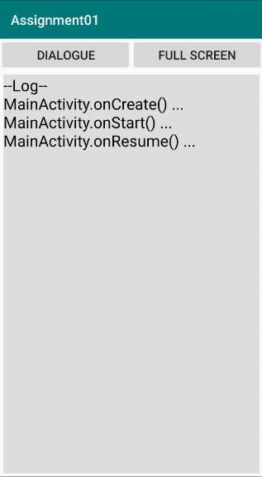 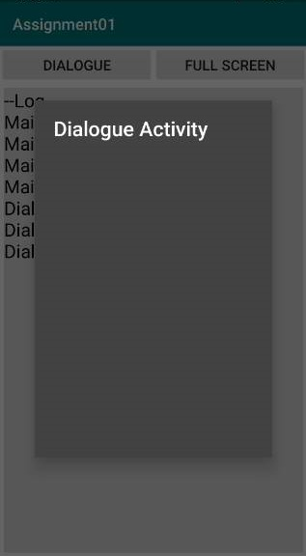 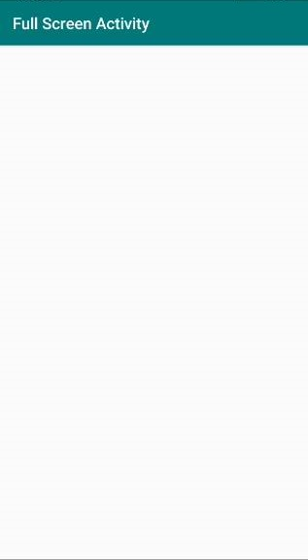

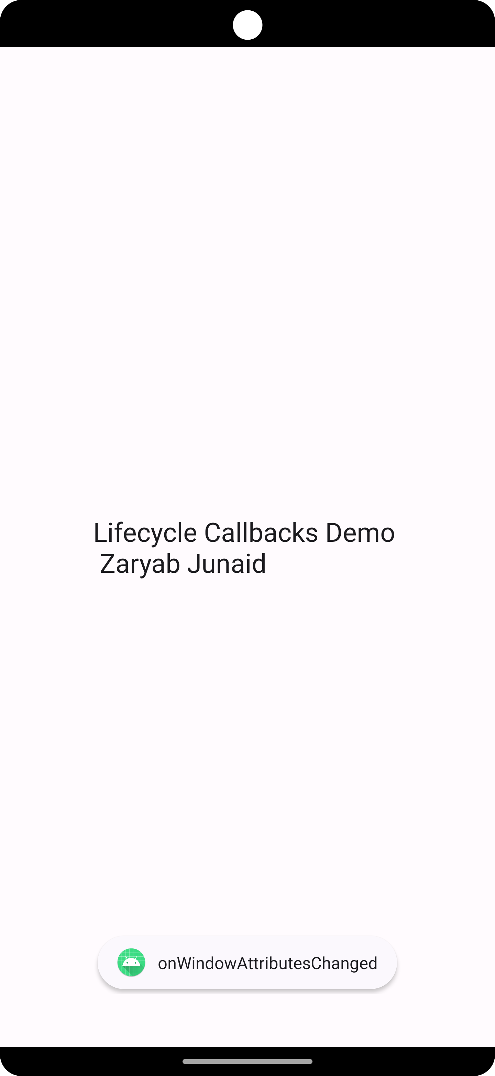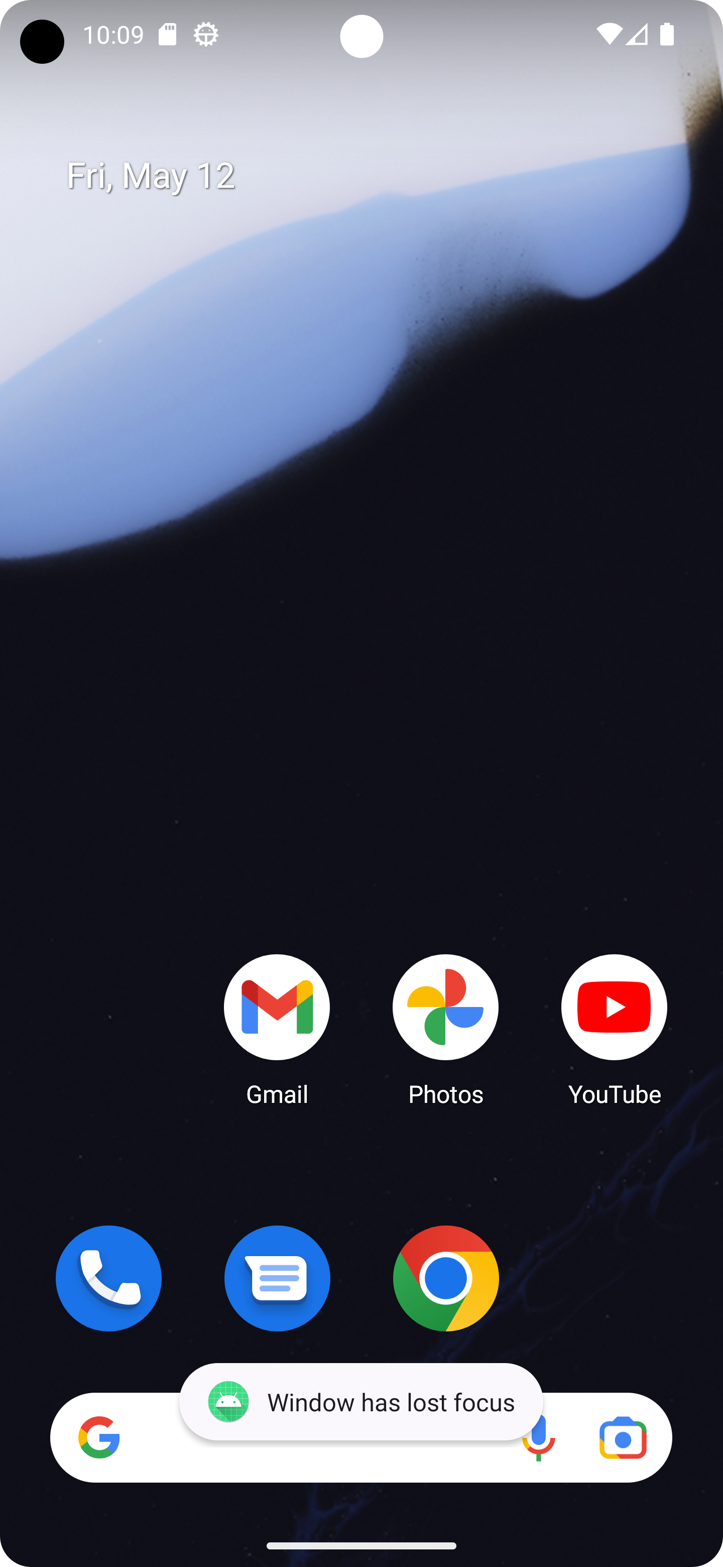

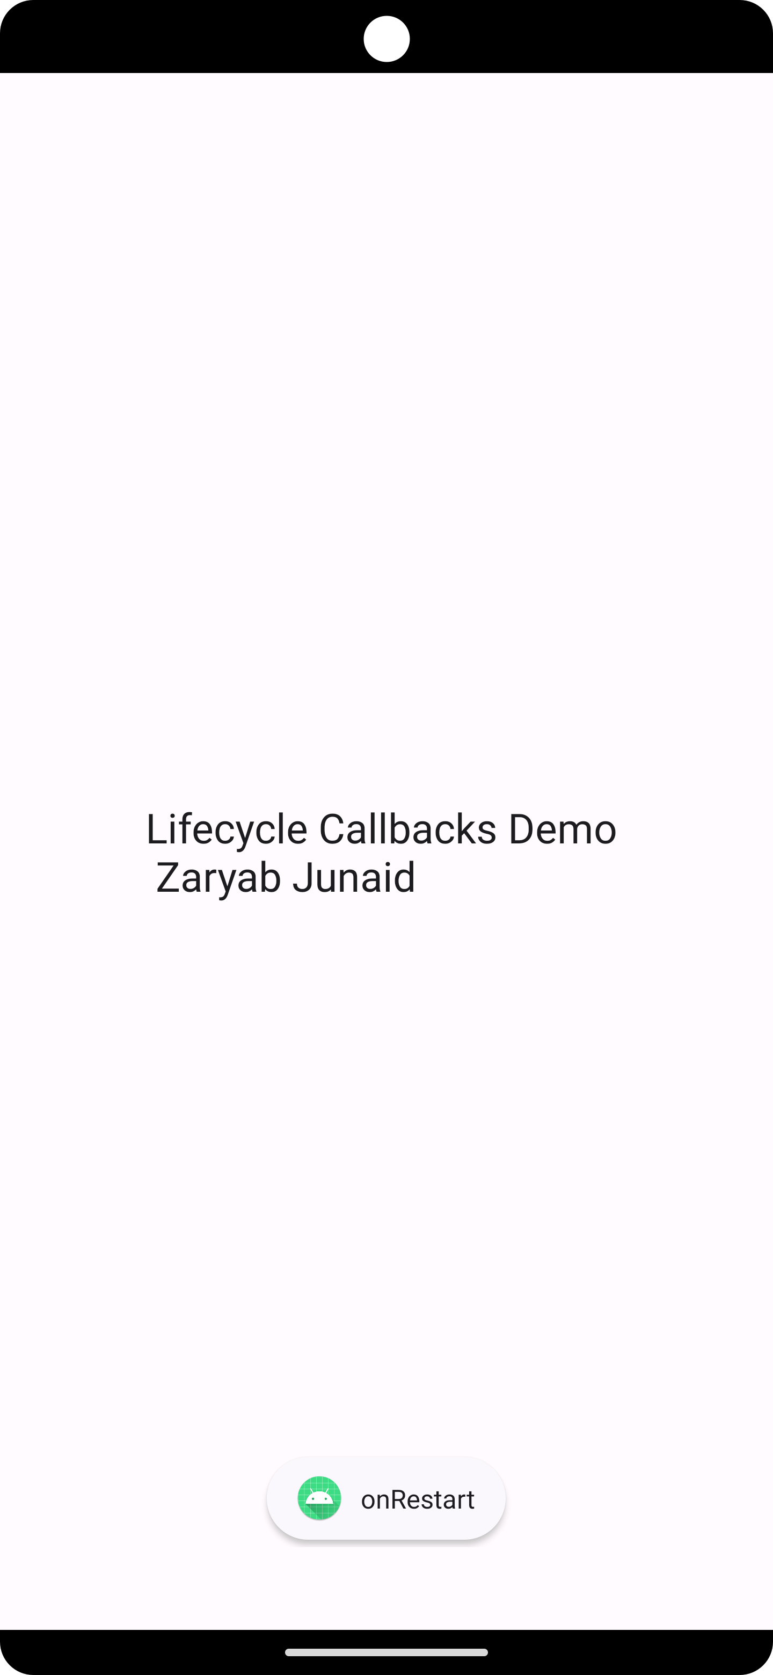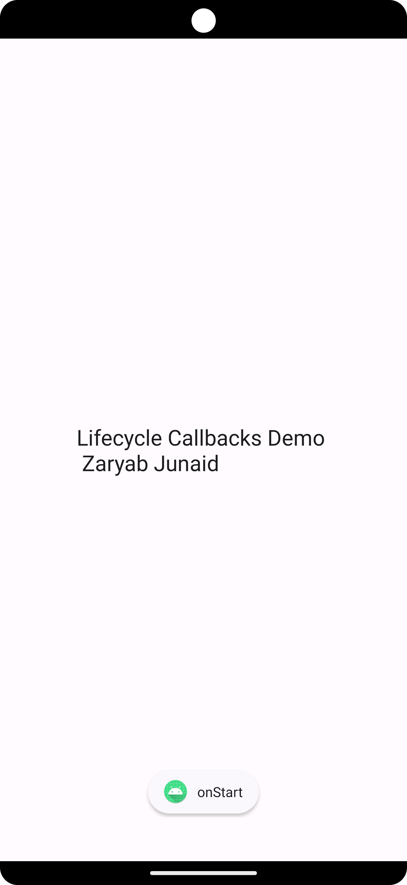

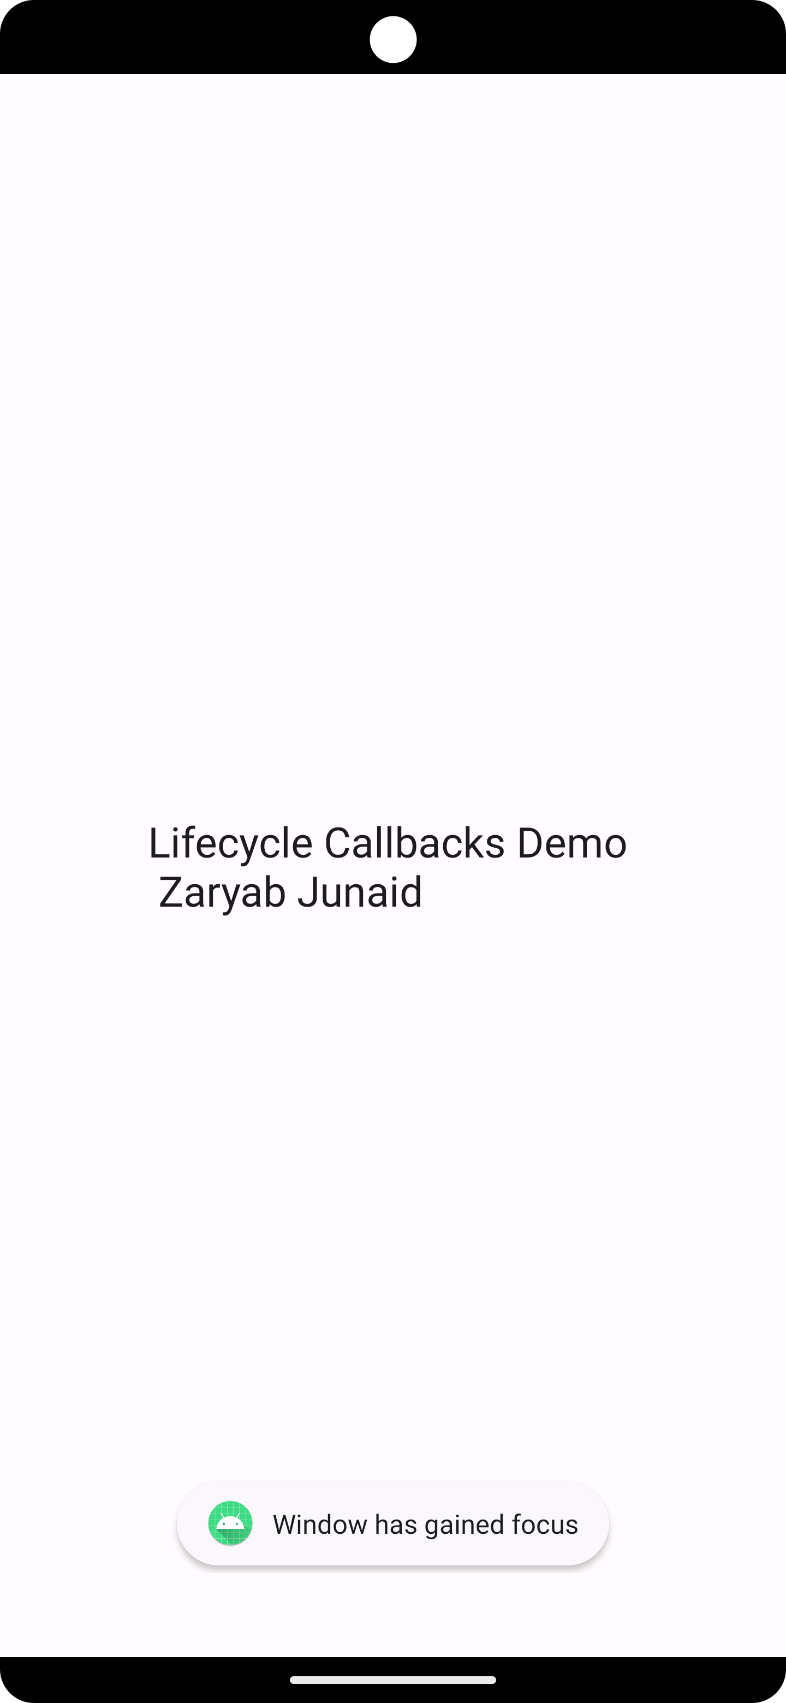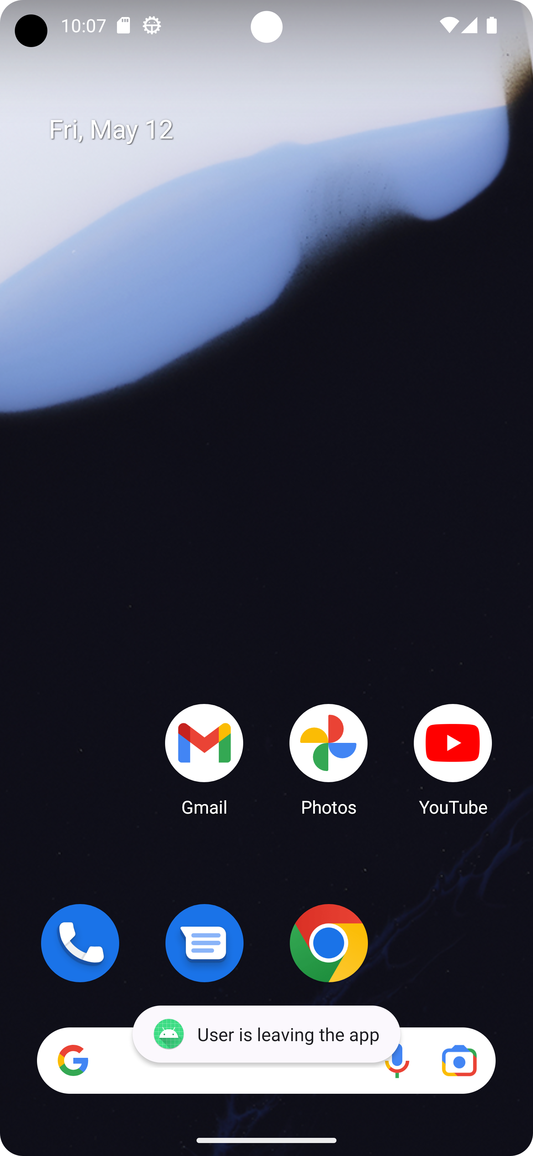

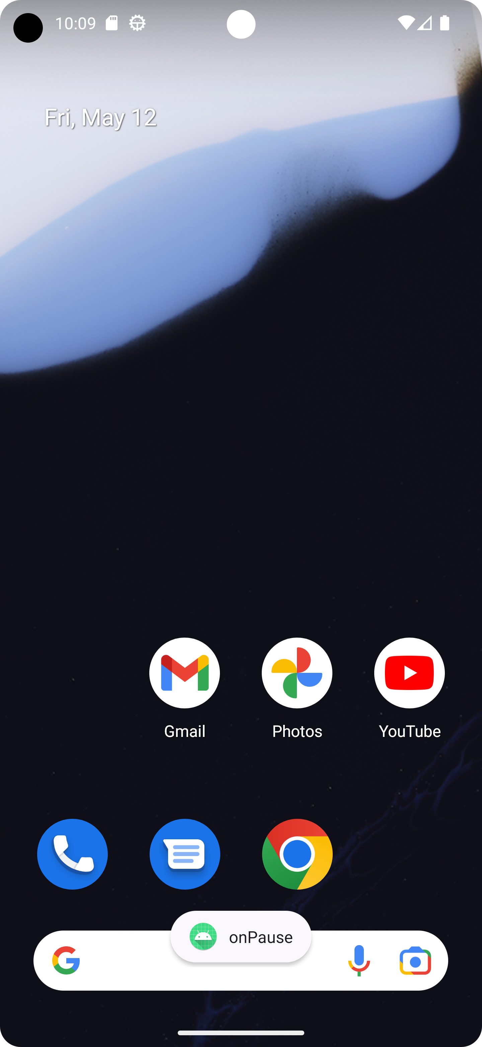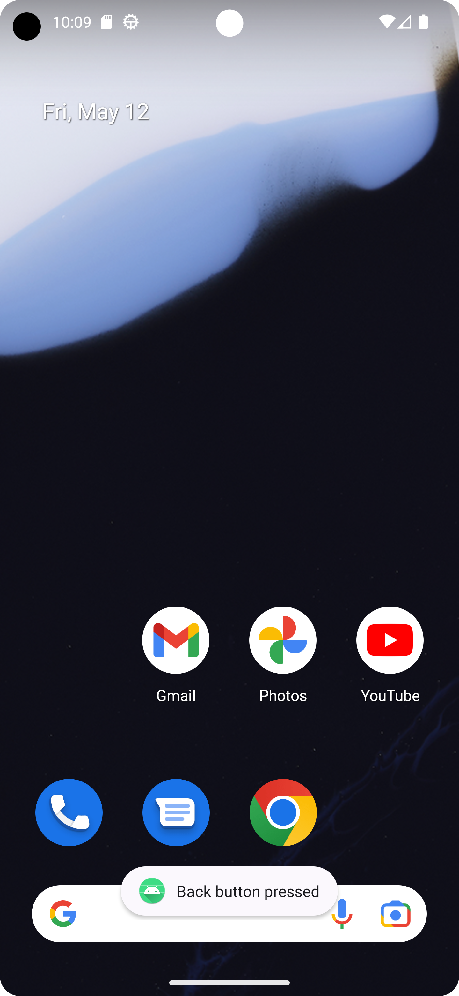

package com.example.myapplication;  
import android.os.Bundle;  
import android.util.Log;  
import android.view.WindowManager;  
import android.widget.Toast;  
  
import androidx.appcompat.app.AppCompatActivity;  
  
public class MainActivity extends AppCompatActivity {  
  
 private static final String *TAG* = "LifecycleDemo";  
  
 @Override  
 protected void onCreate(Bundle savedInstanceState) {  
 super.onCreate(savedInstanceState);  
 setContentView(R.layout.*activity_main*);  
 Log.*d*(*TAG*, "onCreate");  
 Toast.*makeText*(this, "onCreate", Toast.*LENGTH_SHORT*).show();  
 }  
  
 @Override  
 protected void onStart() {  
 super.onStart();  
 Log.*d*(*TAG*, "onStart");  
 Toast.*makeText*(this, "onStart", Toast.*LENGTH_SHORT*).show();  
 }  
  
 @Override  
 protected void onResume() {  
 super.onResume();  
 Log.*d*(*TAG*, "onResume");  
 Toast.*makeText*(this, "onResume", Toast.*LENGTH_SHORT*).show();  
 }  
  
 @Override  
 protected void onPause() {  
 super.onPause();  
 Log.*d*(*TAG*, "onPause");  
 Toast.*makeText*(this, "onPause", Toast.*LENGTH_SHORT*).show();  
 }  
  
 @Override  
 protected void onStop() {  
 super.onStop();  
 Log.*d*(*TAG*, "onStop");  
 Toast.*makeText*(this, "onStop", Toast.*LENGTH_SHORT*).show();  
 }  
  
 @Override  
 protected void onDestroy() {  
 super.onDestroy();  
 Log.*d*(*TAG*, "onDestroy");  
 Toast.*makeText*(this, "onDestroy", Toast.*LENGTH_SHORT*).show();  
 }  
  
 @Override  
 protected void onRestart() {  
 super.onRestart();  
 Log.*d*(*TAG*, "onRestart");  
 Toast.*makeText*(this, "onRestart", Toast.*LENGTH_SHORT*).show();  
 }  
  
 @Override  
 protected void onSaveInstanceState(Bundle outState) {  
 super.onSaveInstanceState(outState);  
 Log.*d*(*TAG*, "onSaveInstanceState");  
 Toast.*makeText*(this, "onSaveInstanceState", Toast.*LENGTH_SHORT*).show();  
 outState.putString("message", "Hello, Saved Instance State!");  
 }  
  
 @Override  
 protected void onRestoreInstanceState(Bundle savedInstanceState) {  
 super.onRestoreInstanceState(savedInstanceState);  
 Log.*d*(*TAG*, "onRestoreInstanceState");  
 Toast.*makeText*(this, "onRestoreInstanceState", Toast.*LENGTH_SHORT*).show();  
 if (savedInstanceState != null) {  
 String message = savedInstanceState.getString("message");  
 Toast.*makeText*(this, message, Toast.*LENGTH_SHORT*).show();  
 }  
 }  
  
 @Override  
 public void onAttachedToWindow() {  
 super.onAttachedToWindow();  
 Log.*d*(*TAG*, "onAttachedToWindow");  
 Toast.*makeText*(this, "onAttachedToWindow", Toast.*LENGTH_SHORT*).show();  
 getWindow().setFlags(WindowManager.LayoutParams.*FLAG_FULLSCREEN*, WindowManager.LayoutParams.*FLAG_FULLSCREEN*);  
 }  
  
 @Override  
 public void onWindowFocusChanged(boolean hasFocus) {  
 super.onWindowFocusChanged(hasFocus);  
 Log.*d*(*TAG*, "onWindowFocusChanged");  
 if (hasFocus) {  
 Toast.*makeText*(this, "Window has gained focus", Toast.*LENGTH_SHORT*).show();  
 } else {  
 Toast.*makeText*(this, "Window has lost focus", Toast.*LENGTH_SHORT*).show();  
 }  
 }  
  
 @Override  
 public void onUserLeaveHint() {  
 super.onUserLeaveHint();  
 Log.*d*(*TAG*, "onUserLeaveHint");  
 Toast.*makeText*(this, "User is leaving the app", Toast.*LENGTH_SHORT*).show();  
 }  
  
 @Override  
 public void onBackPressed() {  
 super.onBackPressed();  
 Log.*d*(*TAG*, "onBackPressed");  
 Toast.*makeText*(this, "Back button pressed", Toast.*LENGTH_SHORT*).show();  
 }  
  
 @Override  
 public void onWindowAttributesChanged(WindowManager.LayoutParams params) {  
 super.onWindowAttributesChanged(params);  
 Log.*d*(*TAG*, "onWindowAttributesChanged");  
 Toast.*makeText*(this, "onWindowAttributesChanged", Toast.*LENGTH_SHORT*).show();  
 if (params.screenBrightness == WindowManager.LayoutParams.*BRIGHTNESS_OVERRIDE_OFF*) {  
 Toast.*makeText*(this, "Screen brightness turned off", Toast.*LENGTH_SHORT*).show();  
 }  
 }  
}

Xml file:

<LinearLayout xmlns:android="http://schemas.android.com/apk/res/android"  
 xmlns:tools="http://schemas.android.com/tools"  
 android:layout_width="match_parent"  
 android:layout_height="match_parent"  
 android:orientation="vertical"  
 android:gravity="center"  
 android:padding="16dp"  
 tools:context=".MainActivity">  
  
 <TextView  
 android:layout_width="wrap_content"  
 android:layout_height="wrap_content"  
 android:text="Lifecycle Callbacks Demo \n Zaryab Junaid"  
 android:textAppearance="@android:style/TextAppearance.Large" />  
  
</LinearLayout>